What is a Distribution?
A ROS distribution is a versioned set of ROS packages. These are akin to Linux distributions (e.g. Ubuntu). The purpose of the ROS distributions is to let developers work against a relatively stable codebase until they are ready to roll everything forward. Therefore once a distribution is released, we try to limit changes to bug fixes and non-breaking improvements for the core packages (every thing under ros-desktop-full). And generally that applies to the whole community, but for "higher" level packages, the rules are less strict, and so it falls to the maintainers of a given package to avoid breaking changes.
ROS版本是一个ROS包的发布版本的集合。
We capture the components that make up a distribution in our rosdistro format and it allows for multiple distributions. There are many different types of robots with different needs, and we anticipate that parts of the community may put together their own distributions in the future to better target these platforms.

List of Distributions

Distro | Release date | Poster | Tuturtle, turtle in tutorial | EOL date
ROS Kinetic Kame  (Recommended) | May 23rd, 2016 | 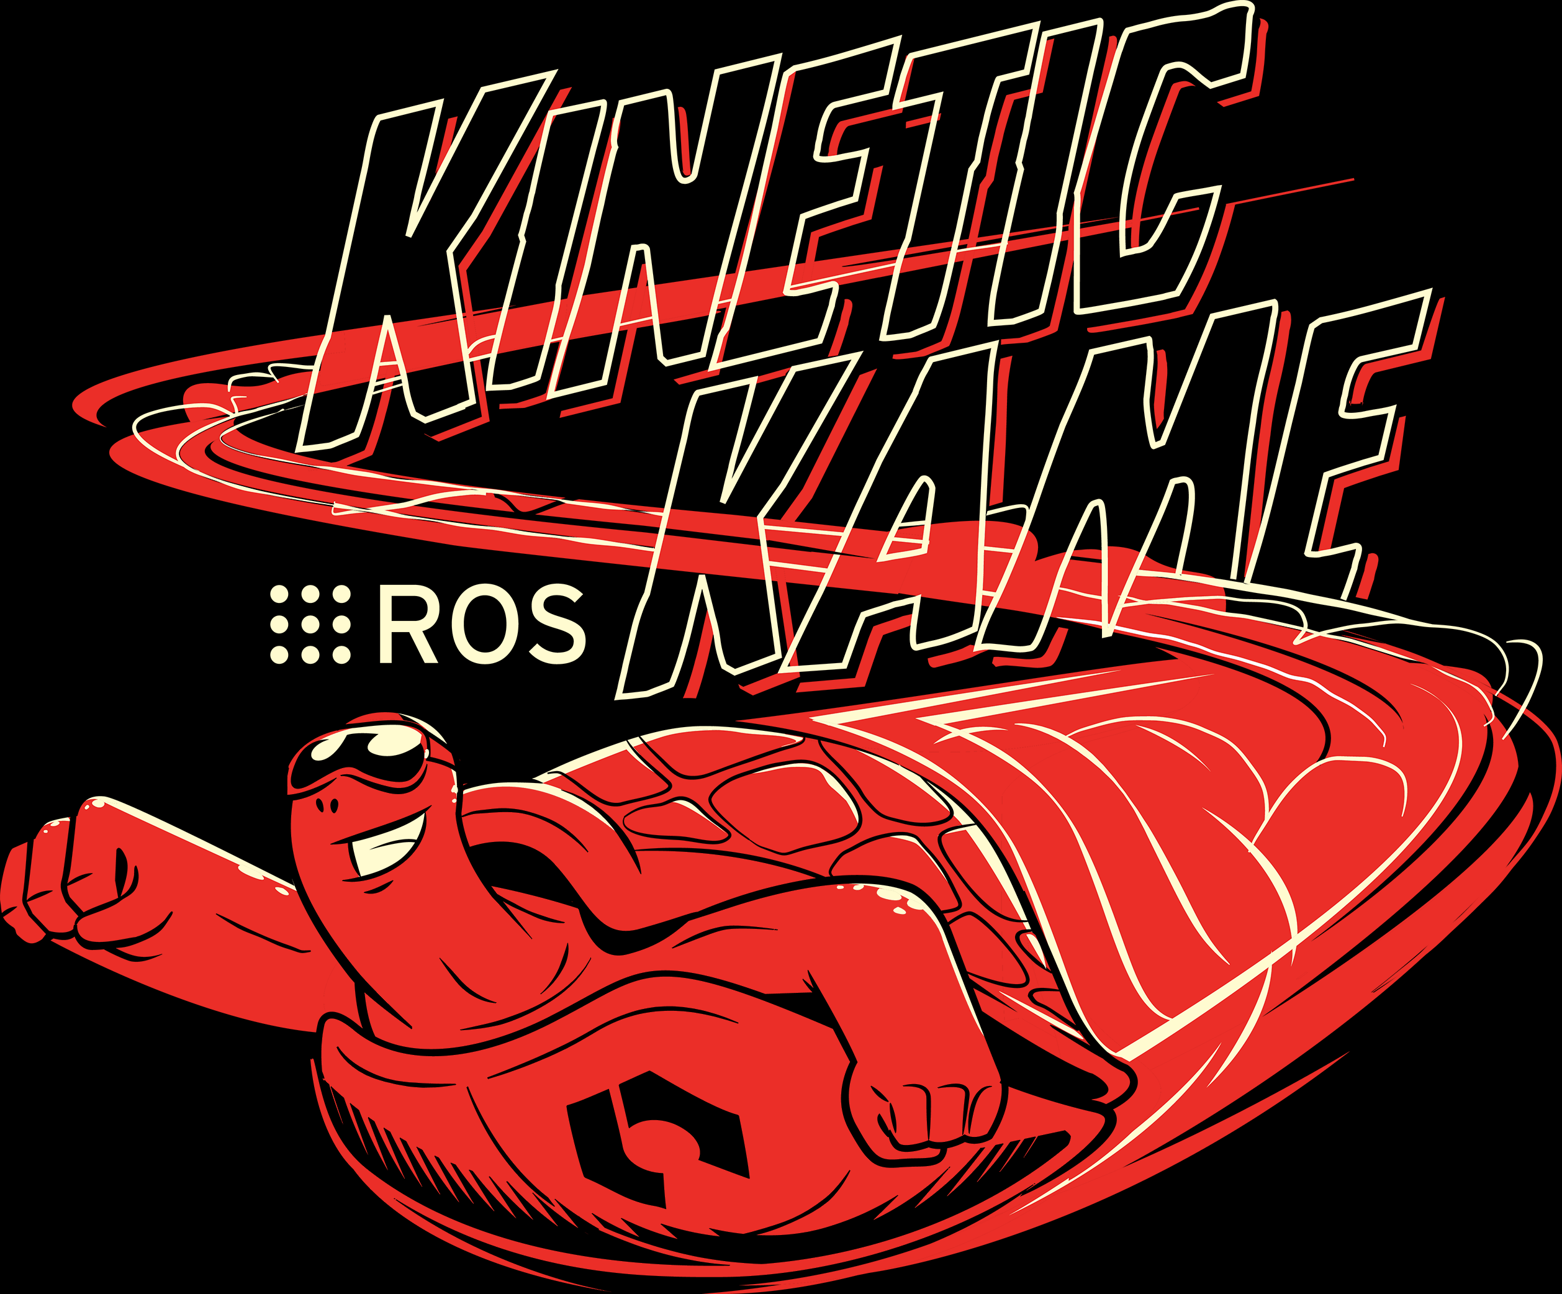 |  | May, 2021
ROS Jade Turtle | May 23rd, 2015 | 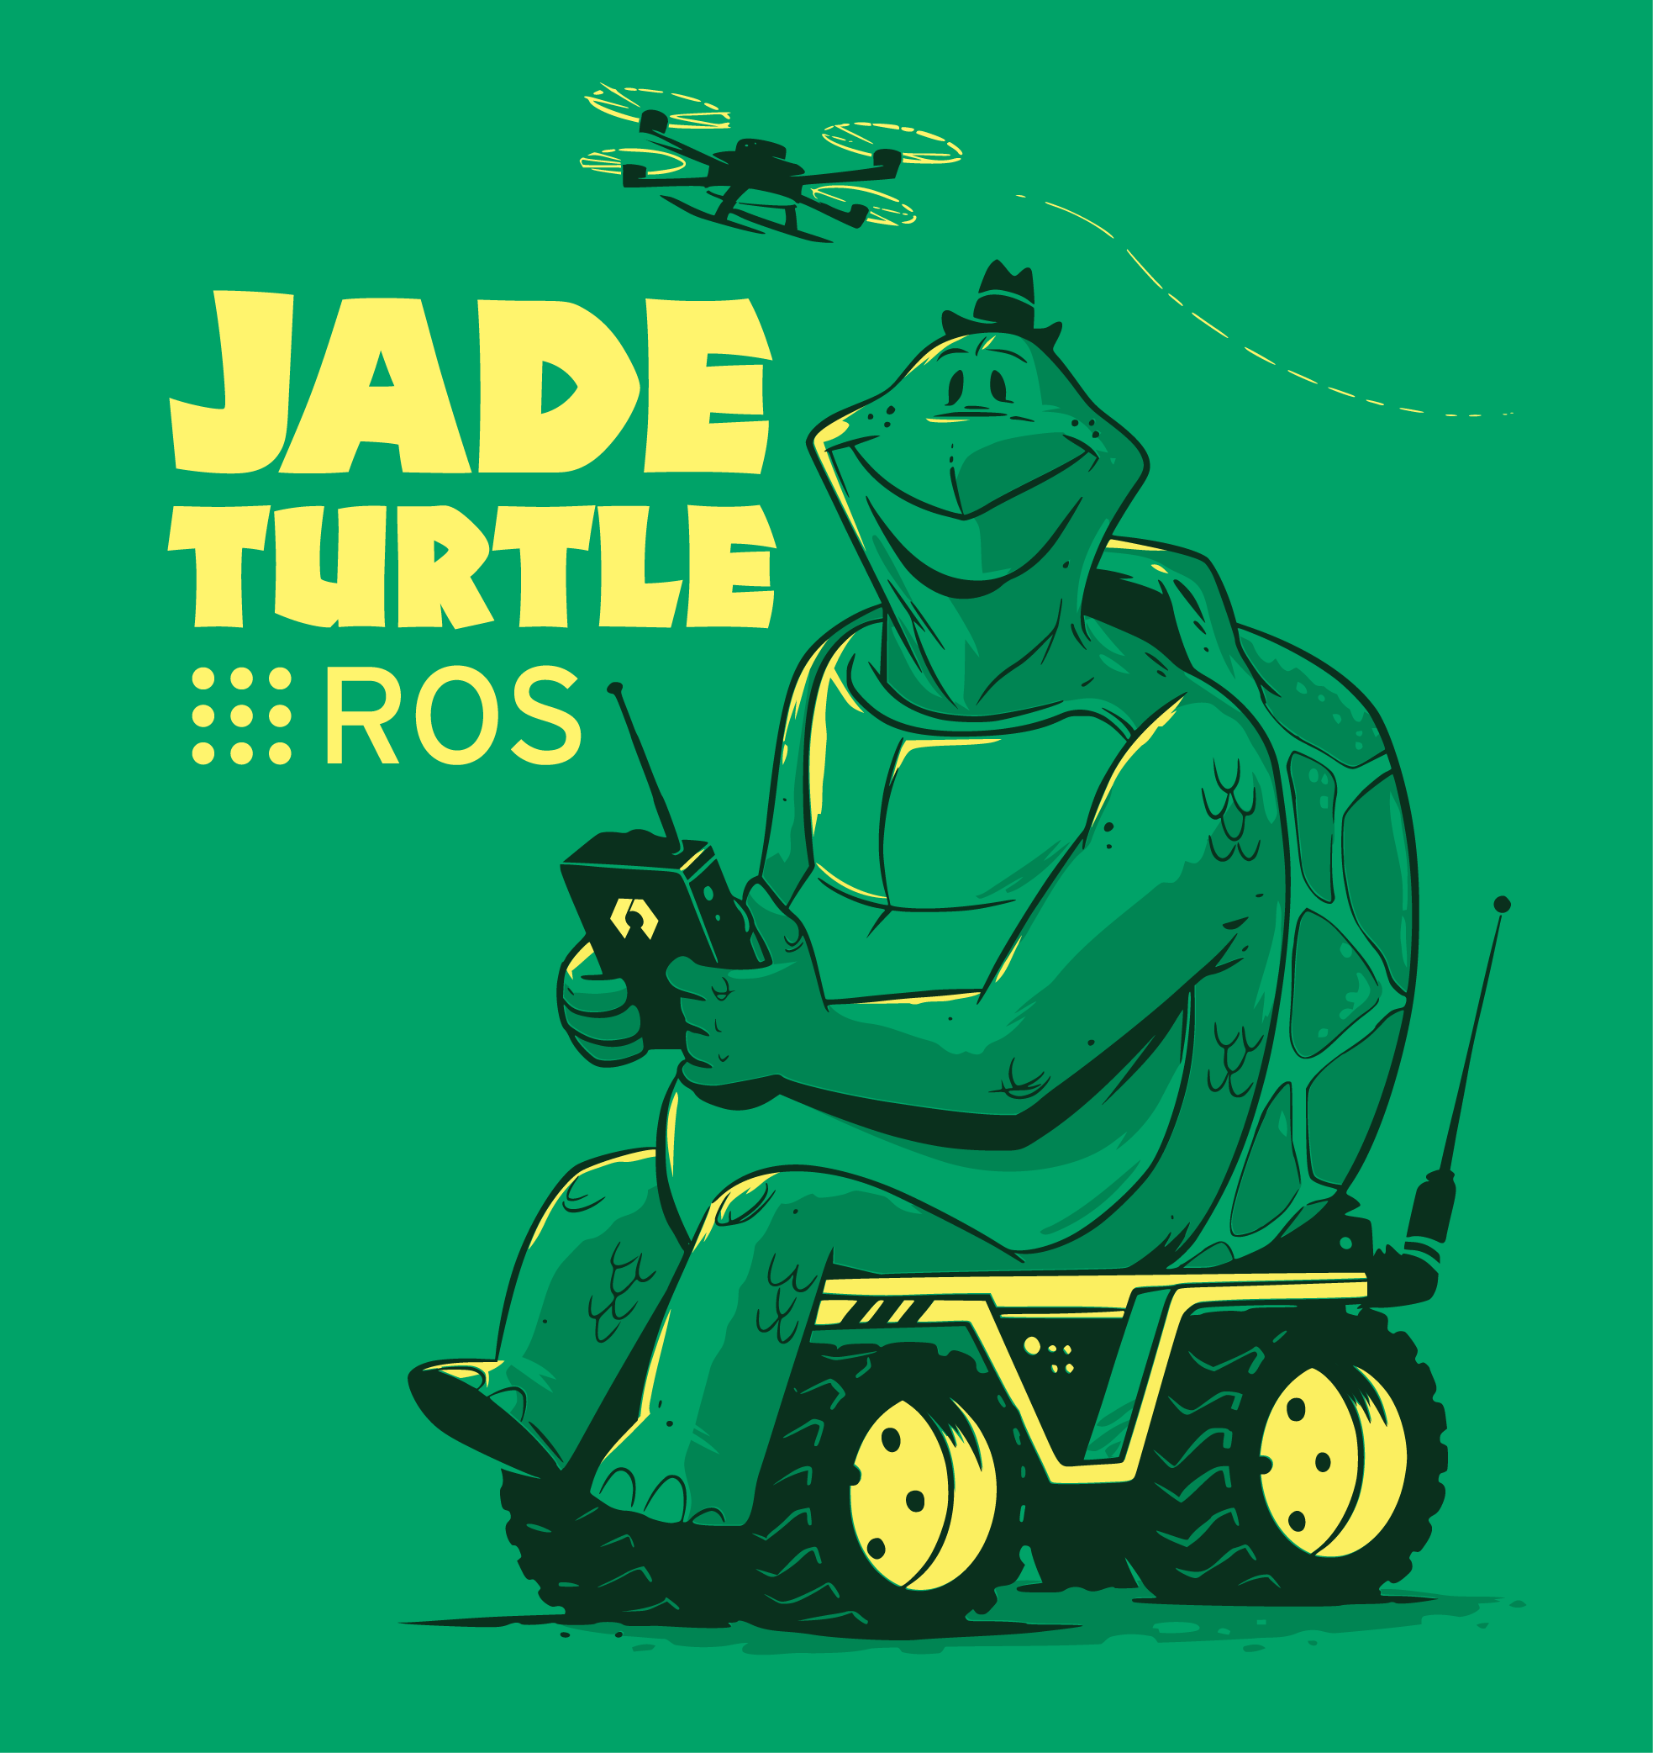 |  | May, 2017
ROS Indigo Igloo | July 22nd, 2014 | 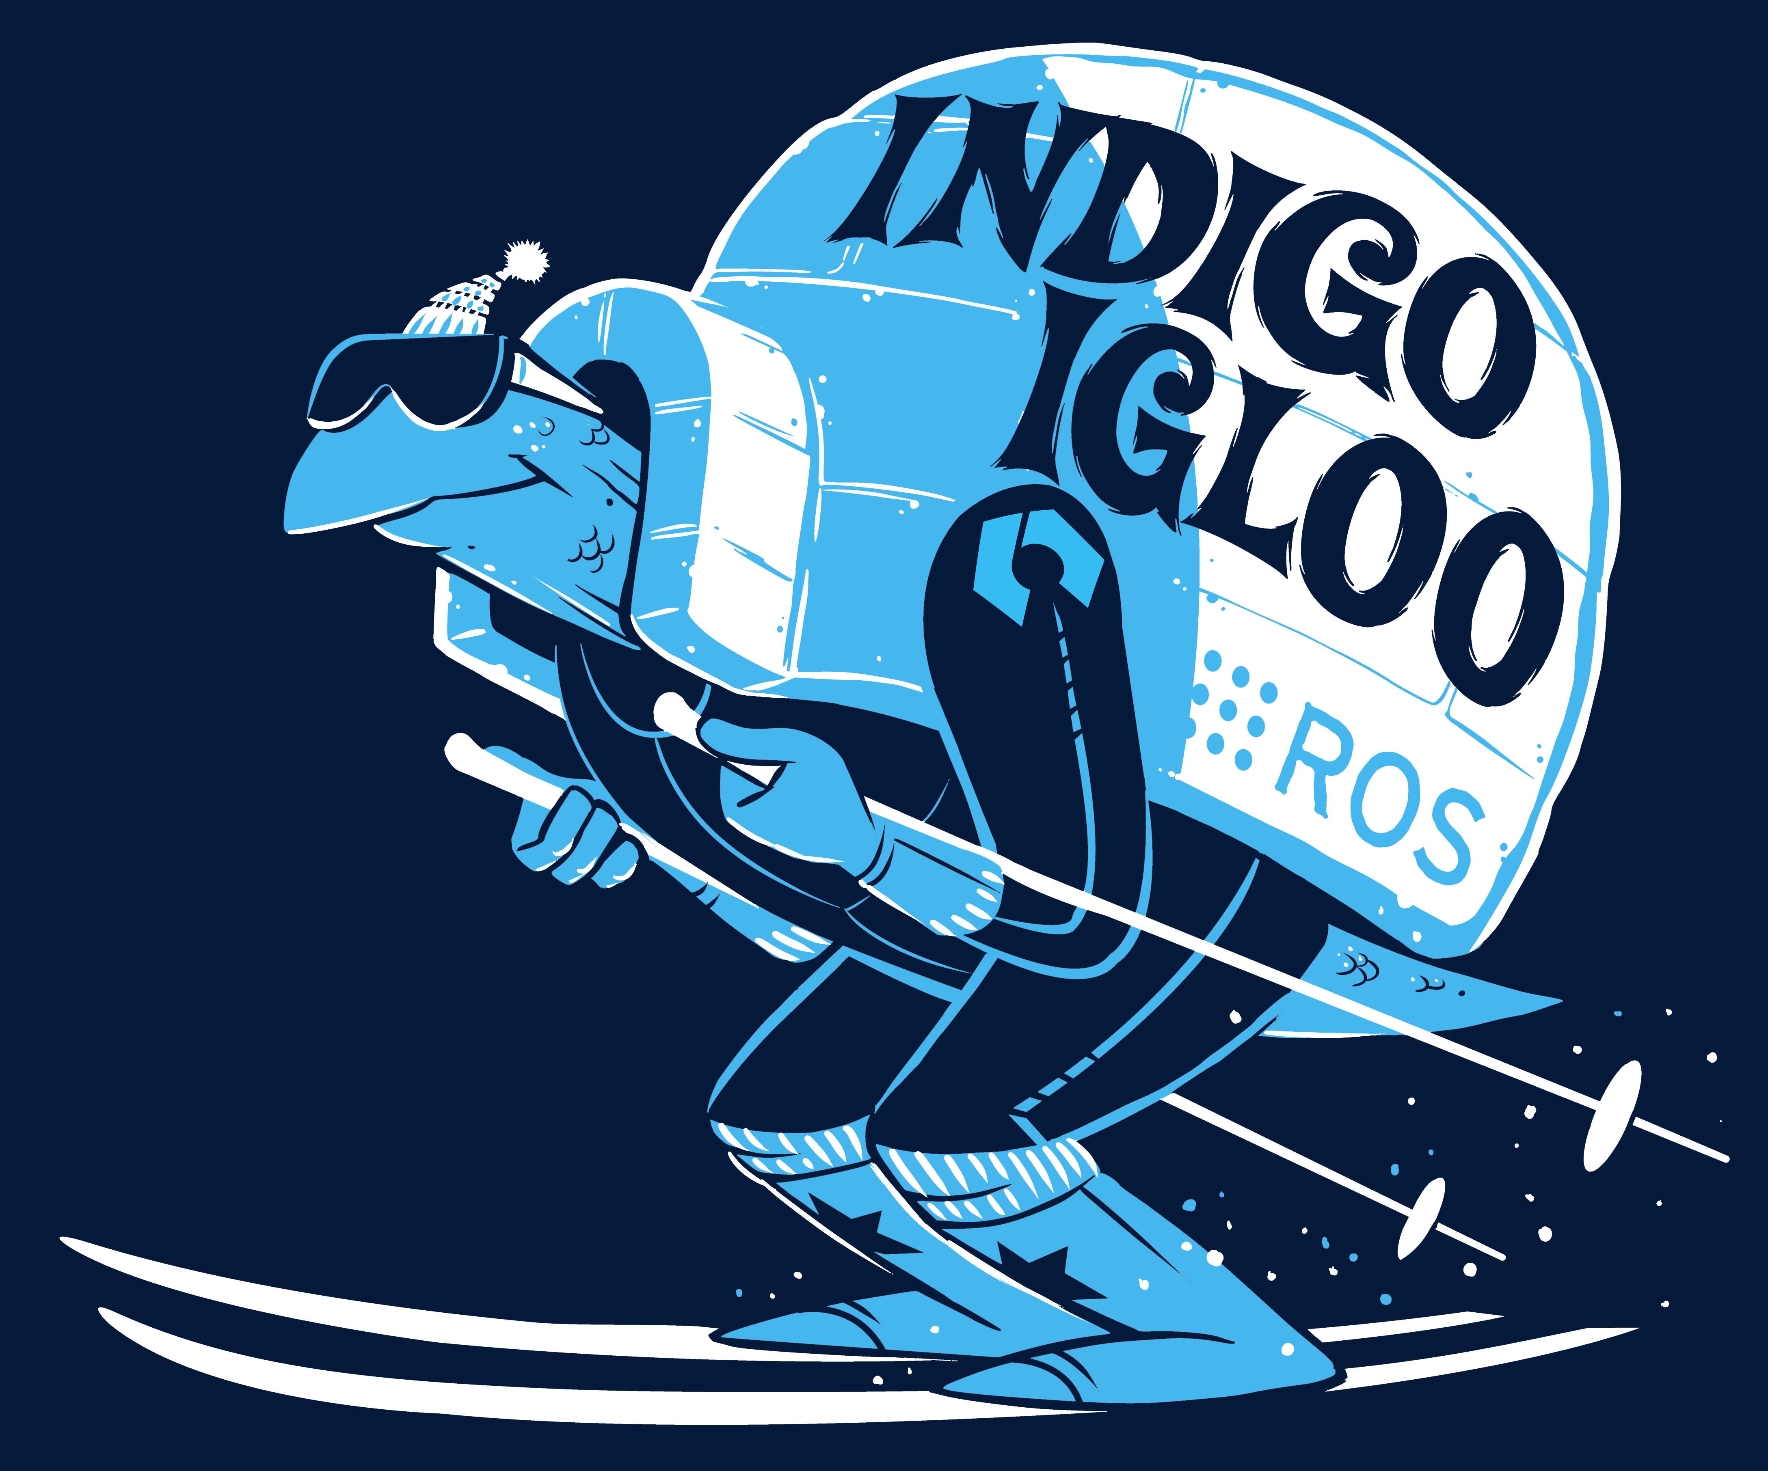 |  | April, 2019  (Trusty EOL)
ROS Hydro Medusa | September 4th, 2013 | 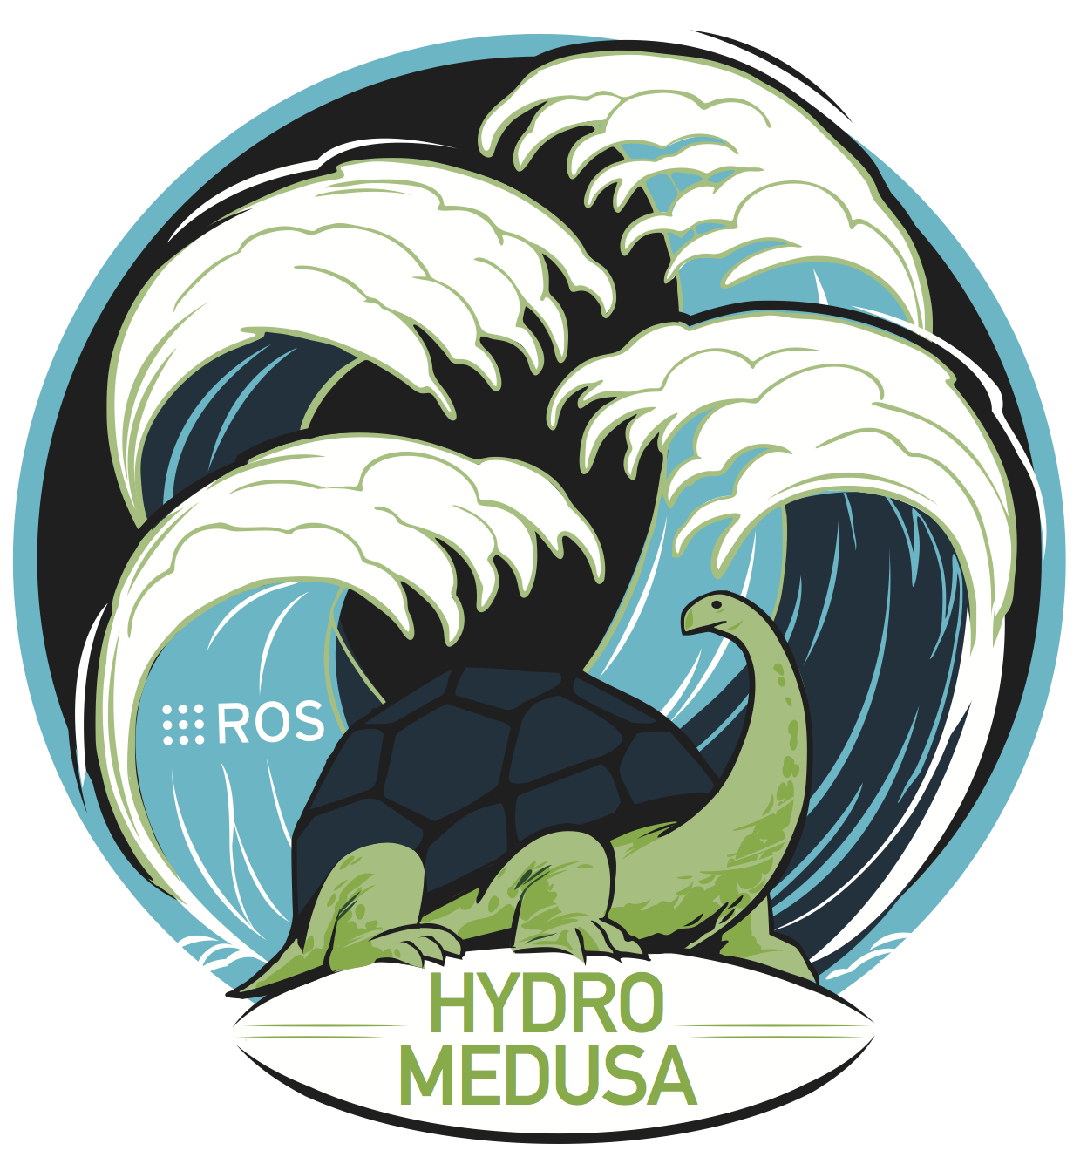 |  | May, 2015
ROS Groovy Galapagos | December 31, 2012 |  |  | July, 2014
ROS Fuerte Turtle | April 23, 2012 |  |  | --
ROS Electric Emys | August 30, 2011 | 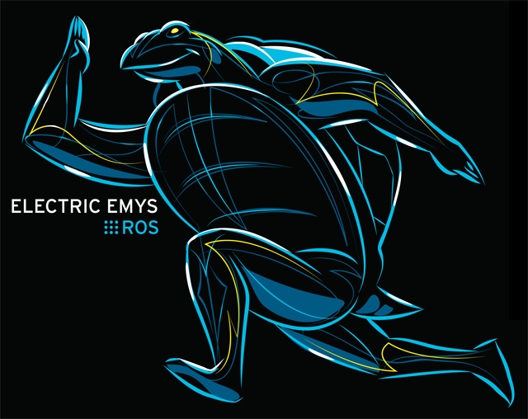 |  | --
ROS Diamondback | March 2, 2011 |  |  | --
ROS C Turtle | August 2, 2010 | 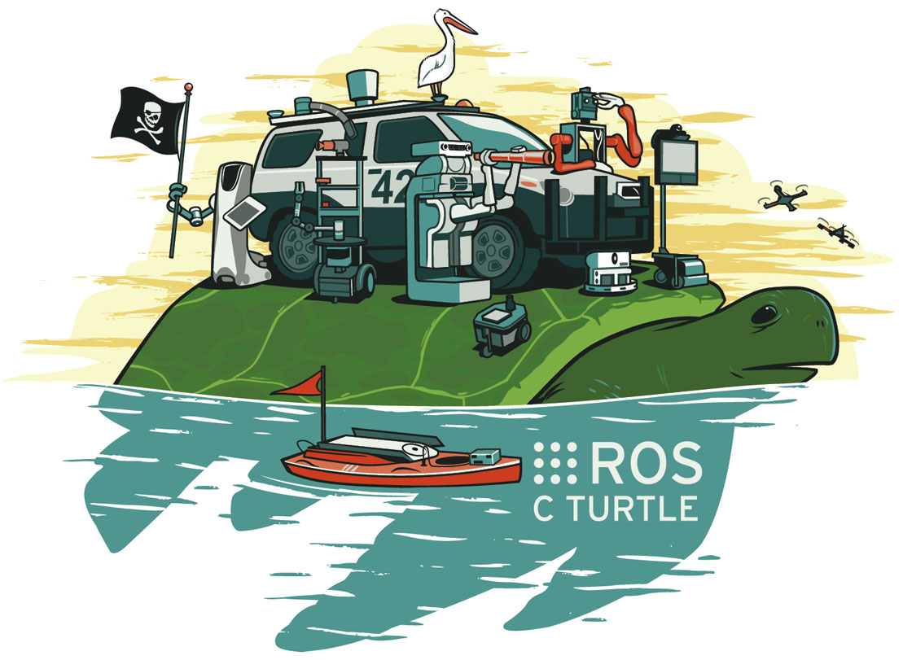 |  | --
ROS Box Turtle | March 2, 2010 | 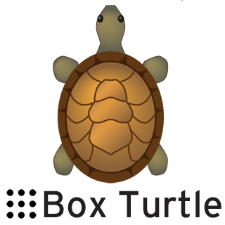 |  | --

Distribution Details
The details on the distributions and versions of common dependencies and other considerations, see the official Target Platforms REP:
- Target Platforms (REP 3)

Release Schedule
Release rules:
- There is a ROS release every year in May.
- Releases on even numbered years will be a LTS release, supported for five years.
- Releases on odd numbered years are normal ROS releases, supported for two years.
- ROS releases will drop support for EOL Ubuntu distributions, even if the ROS release is still supported.
Side effects of the release policy:
- Every ROS release will be supported on exactly one Ubuntu LTS.
- Releases on odd numbered years will share a common Ubuntu release with the LTS ROS release of the previous year.
- LTS releases will not share a common Ubuntu release with any previous releases.
- ROS releases will not add support for new Ubuntu distributions after their release date.
These simplified rules and side effects are subject to change with changes to the underlying Ubuntu release policy.
For more details see the official Release Policy.

Which distribution to use
A rather arbitrary list of usecase driven recommendations.
Functionality | Major Update Frequency | Recommended distro
Preferable but not required | Not appreciated | Latest LTS (Indigo)
Very preferable | Acceptable | Latest (Jade)
Very preferable | Not appreciated | Switch to the latest LTS every 2 year
 | Specific Ubuntu platform is required other than 14.04 | See REP-3
Newer Gazebo is needed |  | Use Jade for Gazebo v5 (Indigo supports v2)
I want to use OpenCV3 |  | Indigo or later

